Задание №1

a = int(input())

print(a,'вершины')

m = []

for i in range(a):

m.append(input().split())

print('ввод окончен')

for i in range(a):

sum = 0

k = ''

for j in range(a):

if(m[i][j] == '1'):

sum = sum + 1

k = k + str(j+1) + " "

print("sum =", sum,",", i+1, ":", k)

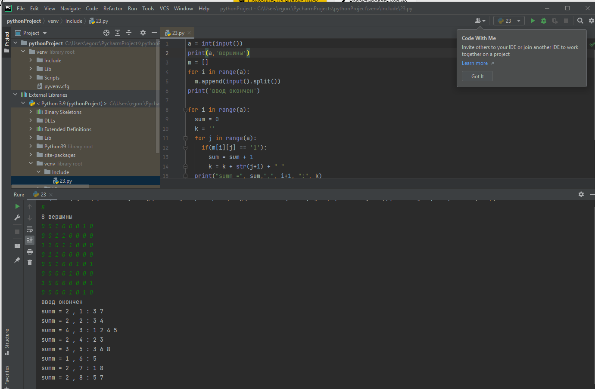

Задание №2

a = int(input())

b = int(input())

arr = []

for i in range (a):

arr.append([])

for i in range(b):

c = input().split()

first = int(s[0])-1

second = int(s[1])-1

arr[second].append(first+1)

arr[first].append(second+1)

for i in range(a):

c = str(sorted(arr[i]))

c= k.replace('[', '')

c= k.replace(']', '')

print(i+1, ":", c)

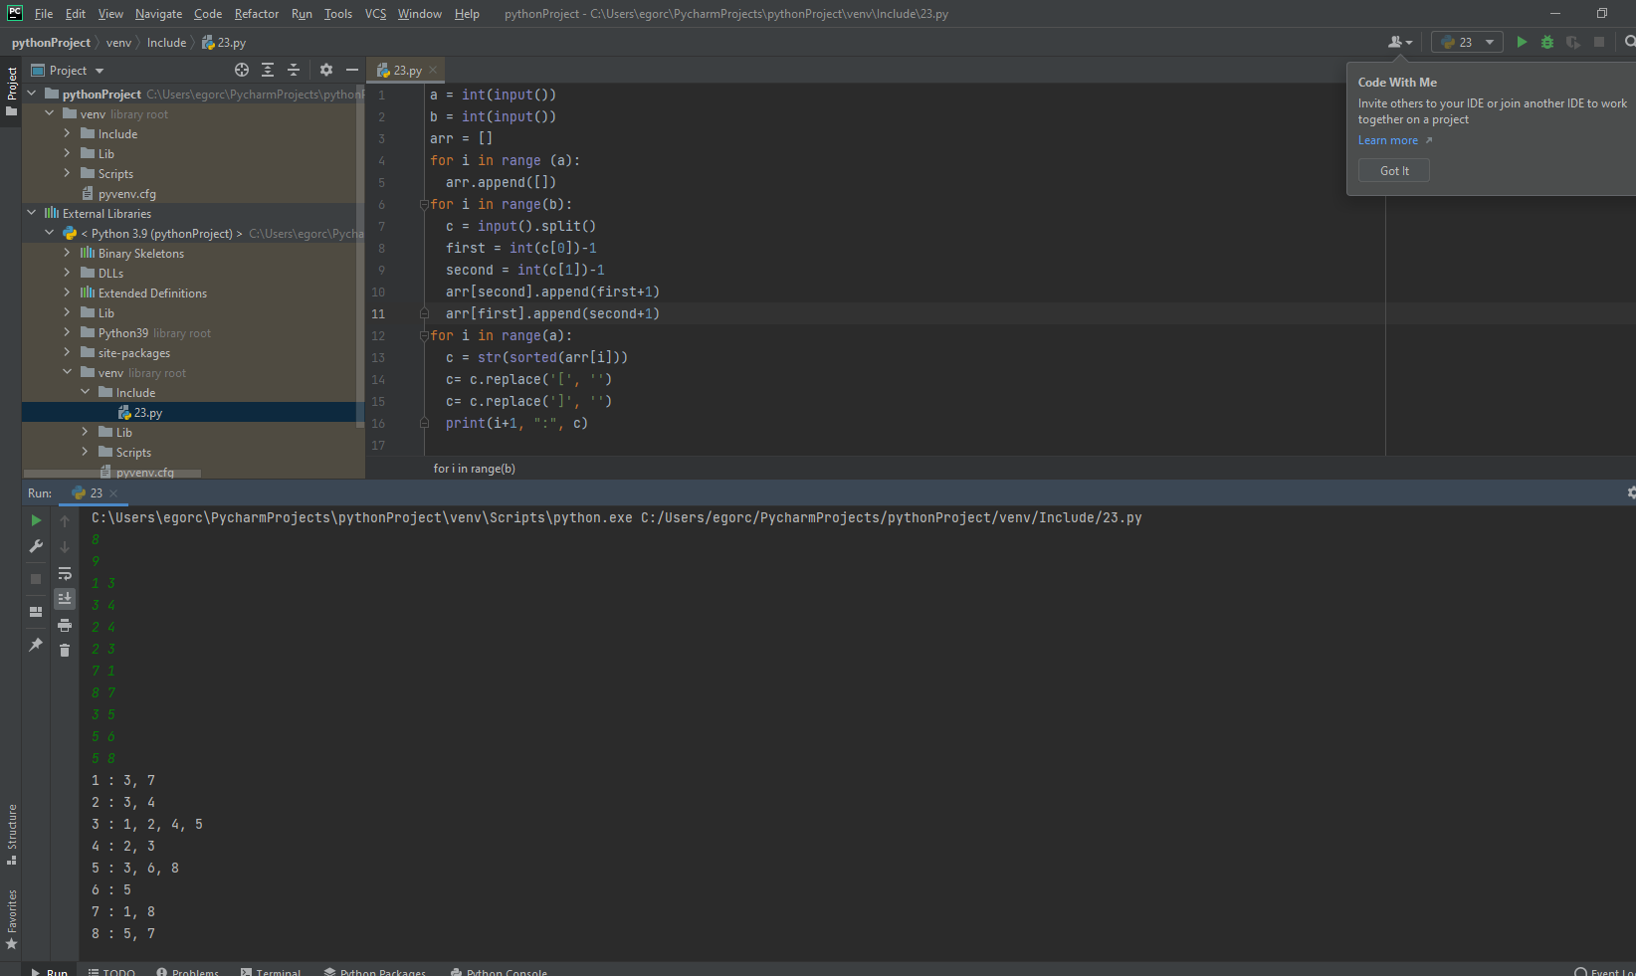

Задание№3

a = int(input("введите количество вершин: "))

lst = []

pairs = []

print("введите список смежности по типу '1:3,2' ")

for i in range(a):

c = input().split(":")

c[1] = c[1].split(',')

lst.append(c[1])

for i in range(a):

for j in range(len(lst[i])):

pairs.append([int(i+1),int(lst[i][j])])

print("Ввод окончен")

pairs2 = pairs.copy()

for i in range(len(pairs)):

for j in range(len(pairs)):

f1 = int(pairs[i][0])

f2 = int(pairs[j][0])

z1 = int(pairs[i][1])

z2 = int(pairs[j][1])

if(f1 == z2 and z1 == f2):

pairs2.remove(pairs[i])

pairs[i].reverse()

print("Список ребер:")

for i in range(len(pairs2)):

print(pairs2[i])

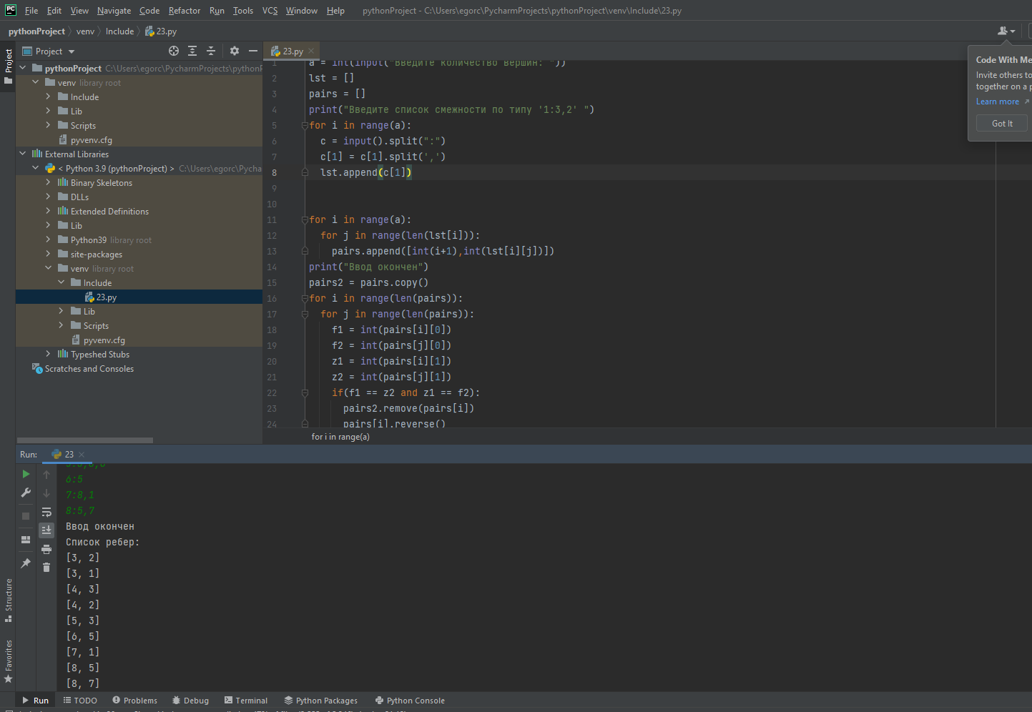

Задание №4

s1 = input().split()

a = int(s1[1]) # кол ребер

b = int(s1[0]) # кол вершин

arr = [] # список смежности

for i in range (b):

arr.append([])

for i in range(a):

s = input().split()

first = int(s[0])-1

second = int(s[1])-1

arr[second].append(first+1)

arr[first].append(second+1)

c = int(input()) # нач точка

arr_smezh = [False for i in range(len(arr))]

output = []

def dfs(node):

arr_smezh[node-1] = True

output.append(node)

count = 0

for neighbor in arr[node-1]:

if arr_smezh[neighbor-1]:

count = count + 1

if not arr_smezh[neighbor-1]:

dfs(neighbor)

if count == len(arr[node-1]):

output.append(node-1)

dfs(c)

print("cписок смежности:")

print(arr)

print("количество ходов:")

print(len(output))

print("список точек:")

print(output)

